**Risk and Resiliency Tool Instructions**

Setting up Environments:

* Place the streamstats, geopy, requests and xlwt folders in this folder: C:\Program Files\ArcGIS\Pro\bin\Python\envs\arcgispro-py3\Lib
* You will likely need an admin to enter their password to copy to that folder.
* Only use the provided StreamStats library, as watershed.py has been altered from what is made available by the API on github in order to retrieve flow statistics.
* The 980 culverts identified as poor condition / high criticality are located in “CulvertsAADTTrafficJoin.zip”. This will be your Culvert Dataset input. **There is a separate SOP called R&R Culverts AADT.doc for creating this dataset, as it requires the creation view using a multi-field join with the AADT data on C-Plan**.
* The Risk and Resiliency Batch tool requires an additional input for StreamStats flows obtained from the StreamStats batch processor joined with the culverts. There is a separate SOP for creating this dataset as well.
* The included RRCulverts_TMDelivery1_8May2020 shapefile will be your Detour Dataset input
* In order to run the tool you must either be connected to the CDOT VPN or have access to the ESRI licensing server.

**Using the Risk and Resiliency StreamStats API Tool:** As of 8/19/20 this tool is best used for running culverts that are not a part of the 980 high criticality/poor condition culverts included with the install. This script makes calls directly to the StreamStats API for both basin characteristics and flow statistics. This tool is slow to run than the batch processor tool due to making two separate calls per culvert, but requires less data preparation.

* Open ArcGIS Pro and open the Catalog pane
* Right click on Toolboxes > Add Toolbox

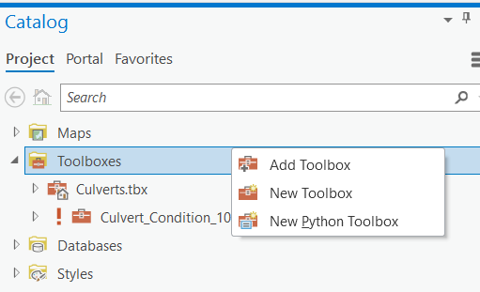

* Navigate to RiskResiliency_StreamStatsAPI.pyt, select press OK
* The Risk and Resiliency tool will have fields for two inputs and an output folder

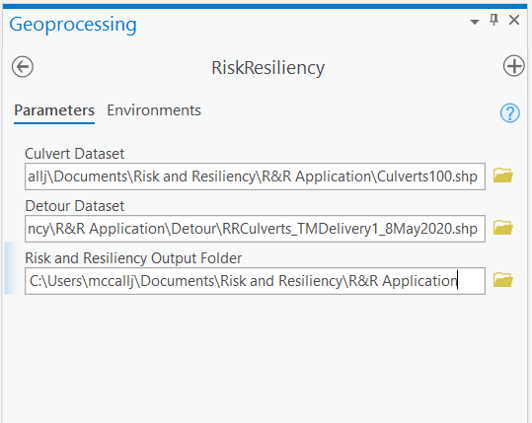

* Culvert Dataset will ask you to select the culvert dataset sample you wish to you – this can be the full 980 culverts or a sample.
* Detour Dataset will require the detour data for the 980 culverts. As of 8/19/20 the latest version is a file named RRCulverts_TMDelivery2_15June2020, but this will likely be updated in the future.
* Risk and Resiliency Output Folder will be the path where both the output spreadsheet as well as a log will be generated. The output spreadsheet will contain output fields described in the Small Culvert risk mitigation planning document. The log will contain information for each culvert in the model run, including culvert lat/longs, dimensions, streamstats output data and other relevant data that can be used for accuracy assessment.

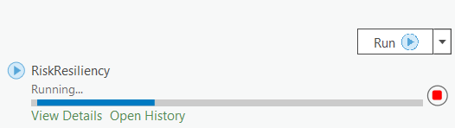

* Once desired inputs and output folder are selected, click Run.
* You can view the script progress and output by clicking View Details

**Using the Risk and Resiliency StreamStats Batch Processor Tool:** As of 8/19/20 this tool is best used for running culverts that *are* a part of the 980 high criticality/poor condition culverts included with the install. This tool is faster to run due to only pulling basin characteristics from the StreamStats API, but requires requesting your flows for each culvert from the StreamStats batch processor. The StreamStats batch process can be very slow – it took 10 days to retrieve flows for all 980 culverts in 9 requests. StreamStats requires making requests of 10 points or less, the time in queue can be lengthy, and time to process your 100 points will be from 2.5-3 hours.

* Follow the same process as opening theRisk and Resiliency StreamStats API tool, only navigate to a file called RiskResiliency_Batch.pyt
* Using this tool is identical to using the RiskResiliency_StreamStatsAPI.pyt tool, with the exception of an input called Batch Processor Flows Dataset.
* Creation of the Batch Processor Flows Dataset requires a separate process detailed in Batch Processor Flows Dataset SOP.doc.
* The shapefile containing flows for the High Criticality Poor Condition culverts used for the pilot project are contained in a zip file called **Culverts_flows.zip**.

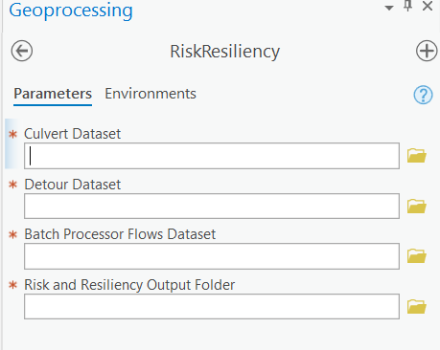

Notes on using the tool:

* You may get a NameError or TypeError when running the script. This appears to be a Python bug that only occurs occasionally with the first culvert – just ignore it and press run again to restart the script.
* N/A No Basin is recorded for culverts where StreamStats delineates a basin for that point where there is no stream
* N/A No Dimensions is recorded when the culvert does not have a Diameter, Box Height or Box Width entered
* User Risk has 0 recorded when additional time/distance is not available for that culvert in the detour data